Lesson 4: Excel Formulas
Excel is just like a calculator. It can:
- Add (+)
- Subtract (-)
- Multiply (*)
- Divide (/)
However, in order to do any sort of calculation, Excel must always begin with an equal sign (=). This is because the cell contains, or will always equal to, the formula and the value it calculates.

Cell References
While you can create simple formulas in Excel manually (for example, =2+2 or =5*5), most of the time you will use the “Point and Click Method” using cell addresses (for example, ) to create a formula. This is known as making a cell reference. Cell references will ensure that your formulas are always accurate because you can change the value of referenced cells without having to rewrite the formula over and over again.
Steps to Create a Formula:
- Select the cell that will contain the formula
- Type the equal sign (=). Notice how it appears in both the cell and the formula bar.
- Type the cell address of the cell you want to reference first in the formula. A blue border will appear around the referenced cell.
- Type the mathematical operator (+, -, etc.) you want to use. See the chart on the next page.
- Type the cell address of the cell you want to reference second in the formula. A red border will appear around the referenced cell.
- Press ENTER on your keyboard. The formula will be calculated, and the value will be displayed in the cell.
There are a number of methods to create a formula. Try the point and click method next time!
Turn to the other side!

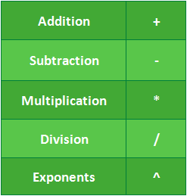
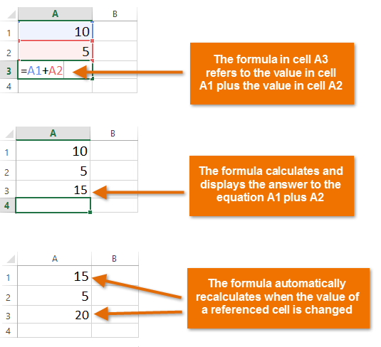

Practice
Write the formula using the “point and click” method and cell references.

 | A | B | C | D
 | Item | Cost x 1 | Quantity | Total $ per Item
1 | Apples | $0.5 | 8 | =B1*C1
2 | Eggs | $7 | 1
3 | Milk | $6.5 | 2
4 | Frozen Pizza | $9.99 | 3
5 | Avocado | $3.00 | 5

