Downloading & Uploading Files
While exploring the Internet, you’ve probably seen the terms downloading and uploading.
Downloading: Receiving data or a file from the Internet on your computer.
Uploading: Sending data or a file from your computer to somewhere on the Internet.

Uploading a File:
- When you’re using social media or are on a website for a job application, you might see an option to add a file or photo. Each website handles this process differently, but you should see a button that prompts you to add a file. It might say: “Upload,” “Add,” “Browse,” or “Attach.” Or it might be an icon of a camera, for example, on a website like Facebook.
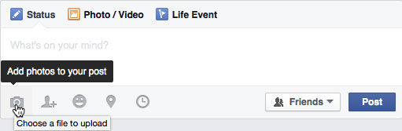
Facebook

- After clicking this button to begin the process, you should see a box pop up. This box asks you to select a file. In this box, you can browse different locations on your computer to see where your files are stored. Scroll up and down on the left navigation bar to see all the locations on the computer where your files might be stored. Your file might be saved on the “Desktop”, a flash drive, or elsewhere. A flash drive will have a name like “REMOVEABLE DISK” or “USB DRIVE.” Or its name might be the brand of your flash drive.

- Click on the location where your file is saved, then find the file itself. You might have saved it in a folder, and in that case you’d double-click on the folder to open it. When you find your file, click on it to select it, then click the “Open” button.

- Depending on the website, your file might automatically upload. However, on some sites (like the example below) you might see an additional button saying “Attach” or “Upload” after you’ve already chosen a file. Click this button to complete the uploading process!
First I clicked “Browse,” chose my file, and clicked “Open.” Now I’m at this screen, and I’ll click “Attach” to finish uploading my file.

____________________________________________________________________________________
Examples of file upload buttons on other websites:
Facebook
Google Drive

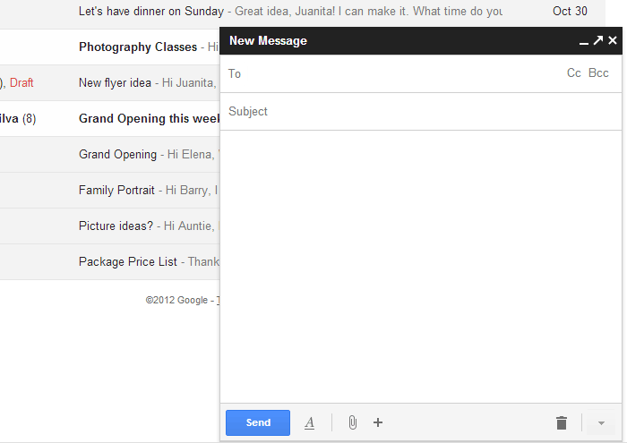
Gmail
- Attaching a file through email

Downloading a File:
- Usually when you download a file, you will start by clicking a link to that file. Again, each website handles this process a little differently. Sometimes you click on a link, which might be the name of a file. In other situations, look for an icon with a downward-facing arrow and click on it. Try clicking around or moving your mouse around the screen to see what options are available to you.

- The exact steps to download a document depend on the Internet browser you’re using. The first step is to click the download link or the downward-facing arrow. In some Internet browsers, next you’ll see a pop-up box that asks you if you’d like to open or save your file. You may see this in Mozilla Firefox. Choose “Open with” to download the file and immediately open it in the specified program on your computer (in this case, Adobe Acrobat). You might have to click this option and then click an “OK” button (see example below). “Save File” will download the file and save it on your computer. These are often automatically saved to the Downloads folder, or you might be asked to choose a place to save the file (like on your computer or flash drive).

- In Internet Explorer, you may see a yellow bar. Like Firefox, Internet Explorer will ask you if you want to open or save the file. Click the one that works for you.
- In other Internet browsers, like Google Chrome, you might see a gray bar at the bottom of your screen that has an icon of the file after it’s been downloaded. If you click on this icon, it will open on your computer in a program.
Click this to open your downloaded file

Downloaded files often go into the Downloads folder on your computer, so if you’re having trouble finding what you downloaded, look here! The Downloads folder is often accessible from the Desktop. You can also find it by going to the Start menu and choosing “Computer” or “This PC,” then looking for the Downloads folder.

