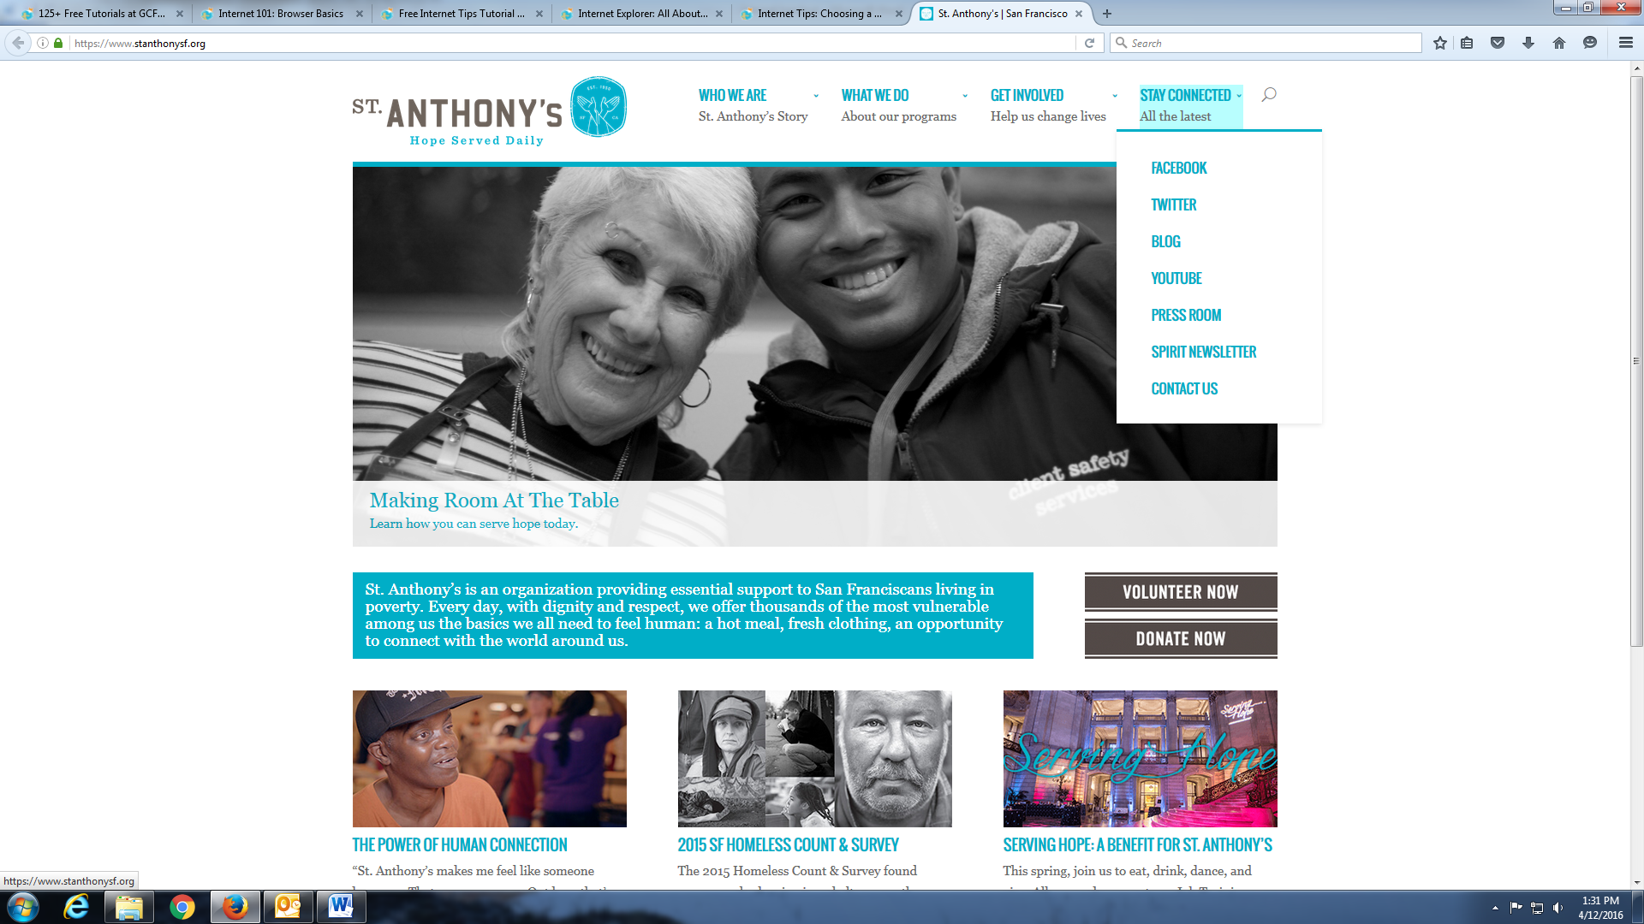

**Parts of a Website**

Website address in the Address Bar

Browser Menus

Tabs (part of browser)

Website’s logo

Navigation bar with menus

Links- when you click them, they’ll take you to another page. The mouse cursor will turn into a little hand like this if you move over a link.

Address bar (part of browser)

Browser window

Back arrow (part of browser)