Lesson 6: Cut, Copy and Paste

What's the difference between copying and cutting?
Think of it like an actual piece of paper, like a letter. When you photocopy the letter, this creates a duplicate and the original stays intact. Cutting a block of text with scissors on the other hand, removes that portion from the letter. You can paste that portion somewhere else, but that block of text from the original letter will no longer be there.
On your computer:
When you “copy” a file, image, text, or other item, it creates a duplicate of that item in your computer's temporary memory.
When you “cut” an item, it will remove it from the original page or folder and hold it in the Clipboard, which is the computer’s memory.
You can almost always copy (duplicate) something, like a phrase on a web page, but cutting is only possible if you have the editing or administrative control of the item. For example, you cannot cut phrases out of web pages you visit in your browser (imagine what the Internet would look like if everyone could!). In those cases, copying the text or image is the best solution.

Once you've cut or copied something into memory, you can then paste it into another document, file, or folder.

To copy and paste text:
- Select the text you want to copy.
- Click the Copy command on the Home tab. You can also right-click your document and select Copy.
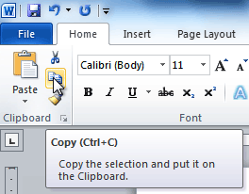
- Place your action bar where you want the text to appear.
- Click the Paste command on the Home tab. The text will appear.

To cut and paste text:
- Select the text you want to copy.
- Click the Cut command on the Home tab. You can also right-click the document and select Cut.
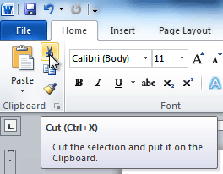
- Place your action bar where you want the text to appear.
- Click the Paste command on the Home tab. The text will appear.
You can also cut, copy, and paste by right-clicking the document and choosing the desired action from the drop-down menu. When you use this method to paste, you can choose from three options that determine how text will be formatted: Keep Source Formatting, Merge Formatting, and Keep Text Only. You can hover the mouse over each icon to see what it will look like before clicking it.
